# Implementing Disk Health File Upload task on Machines.

## Find ps1 files

Find the ps1 file, it is in the IG88 Teams share files at 02 Documentation -> Checklists -> Monthly Checklists -> Disk Storage Health Check named get_disk_space.ps1.

## Create Folders for PowerShell script and output csv

Create a folder in documents and name it “Disk Space Health Check”. Put the get_disk_space.ps1 file into this folder.

Then create a folder in the MoTec Log file- MM48 Logged Data folder (C:\Users\MM48\Phibion Pty Ltd\MoTec Log file - MM48 Logged Data) and name it “Disk Space Health Check Output”.

## File changes and location on

Open the file using notepad and there are 2 things that will need to be changed. Look at the below image for reference.

* The left Circle is where you set the path of the output of file. Change this to the shared One Drive folder Location (make sure it’s between “” )
* The last thing to change is in the same file path rename the last part of it to your machine name followed by .csv (eg MM35.csv if you are putting it on MM35).

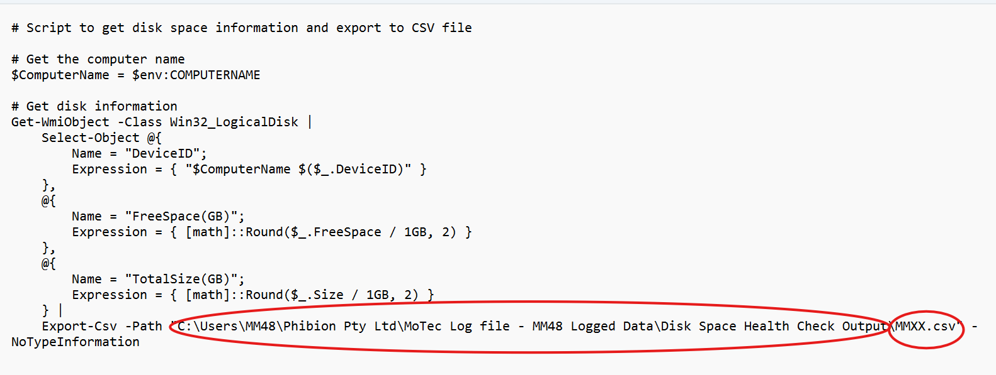

## Schedule Task

* Goto task schedular and navigate to the Microsoft folder in the Tash Scheduler library.
* Click Create Task
* Under each of the tabs in the create task window update as indicated by the table below.

|  |  |
| --- | --- |
| General | Name: Weekly Disk Space Check  Run with highest privileges: tick this box |
| Triggers | Click new   * Begin the task: On a Schedule * Tick Weekly box * Start: 1:30am on the Monday * Tick Stop task if it runs longer than: 30 mins * Tick: enable |
| Actions | Click New   * Action: Start a program * Program/script: powershell.exe * Add arguments (optional): -ExecutionPolicy Bypass -File "your file path to the .ps1 file including the .ps1 file name” * Eg: **-ExecutionPolicy Bypass -File “C:\Users\MM12\Documents\Disk Space Health Check \get_disk_space.ps1”** |

Then test by running task and seeing if a file is outputted.

## Add data to power bi

Navigate to the power bi report located at (add file path).

### Connect the data

Connect to the data. The data can be found in the motec drive for each machine in the MMXX.csv file. An example of the location/file path is “MoTec Log file - General\MM49 Logged Data\Disk Space Health Check Output\MM49.csv” for mm49.

### Add to append 3

Add the MMXX.csv data to append 3 table.